NETWORKING 1

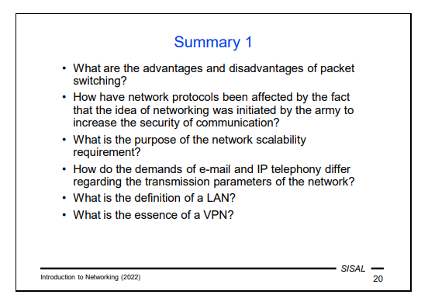
Packet switching is a slower method for communication, but fault-tolerant as opposed to circuit switching that is faster but unreliable.
--------the data is divided into smaller blocks so-called packets and let each packet to find its own way to the target node. If a node is broken, the packet will find an alternate way. It will be delayed a bit, but it will be delivered.
--------circuit switching. This means that when you call someone, the network will find a sequence of nodes (a circuit) needed to connect your device and the end device that you are calling. Once this circuit is established, all audio data follows this path. If the enemy breaks a node in the circuit, the circuit is lost.

The network protocols have been affected in the sense that they needed more security in order to solve the problem of circuit switching not being fault tolerant, so the problem was sollved by the usage of packet-switching.
Or – in the sense that networks have been designed with respect to physical security, by using packet switching instead of circuit switching.
---------The army were solving the major problem of telephone network outages in the event of an enemy attack, which means that the circuit switching would not work for them, as in the case of failure of a node, the whole communication would fail.

What is the purpose of the network scalability requirement?
The purpose of the network scalability requirement is that the system must be designed to make adding a new computer or network easy, without having to make changes in remote locations or parts of the network.
------Scalability leads to logically similar but technically different approaches when adding a host to a (local) network and adding a network to the Internet.

How do the demands of e-mail and IP telephony differ regarding the transmission parameters of the network?
For e-mail, the critical transmission parameters include: low data loss and low latency, contrasting the demans of IP telephony(VoIP), thet require Low jitter: VoIP applications require consistent delivery of packets to maintain the quality of the voice call. High jitter can result in uneven audio quality. And low latency

Definition of LAN?
LAN = Local Area Networks = descendants of terminal networks, which means that their main purpose is to share resources between nearby computers (we can also consider an Internet connection as one of the shared resources). They are usually geographically limited by the boundaries of a building or campus whose owner builds and manages the network primarily for its employees, students, customers, etc. Centralized control, proprietary networks.
--------A recommended approach to design a local network is dividing the infrastructure into three parts: core, distribution, access.
The key device there is a router, a node interconnecting different networks. This router is an entry point of our network, connected to another router on the ISP's side. Another important device is a switch, a node interconnecting other switches and end devices in the network. The core layer of the local network usually contains a few main switches connecting the perimeter router to the rest of the local network.

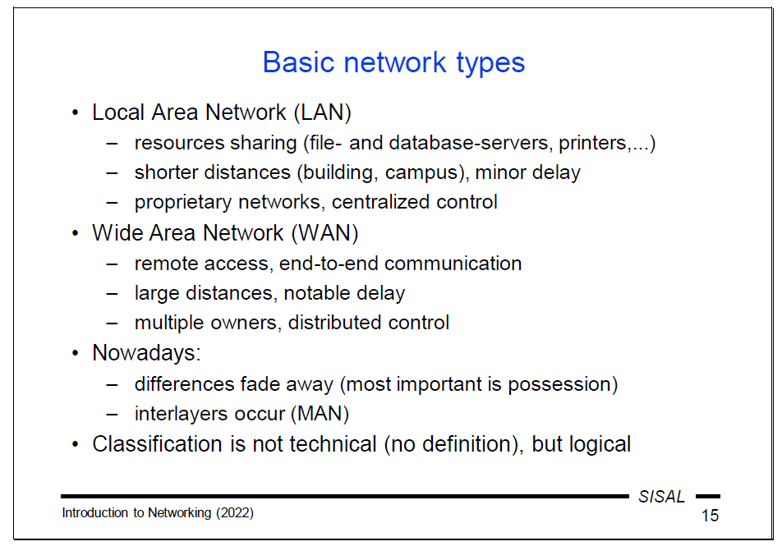

Definition of WAN?
WAN = Wide Area Networks = a global network that has replaced point-to-point connections between computers or computer centers that were built on demand. Its main purpose is interpersonal and inter-computer communication and data transfer. It is built and managed by many companies and used not only by people related to them.

Definition of VPN?
VPN = Virtual Private Network = a solution that allows for the expansion of a private Local Area Network (LAN) geographically over a large area, such as between affiliates in distant cities, without losing privacy. It operates by establishing a secure connection, or "tunnel," between the two LANs over a public network. All traffic directed to the other affiliate is encrypted at the local end of the tunnel, sent over the public network, and then decrypted at the other end before being delivered to the second LAN. For computers in both LANs, this mechanism is transparent, meaning they do not need to be aware of the encryption and decryption processes

